FOR IMMEDIATE RELEASE Contact: <Name>
November 17, 2025 Phone: <XXX–XXX–XXXX>

<Organization> Reminds All Road Users: “SAFETY STARTS WITH YOU – SLOW DOWN AND MOVE OVER!” this Crash Responder Safety Week (CRSW), and Every Week.
Every minute of every day, firefighters, emergency medical service, law enforcement, towing and recovery, public works, safety service patrol, and other transportation professionals work tirelessly to clear roadway crashes, debris, and stalled vehicles. These responders also bring life-saving care to those injured. Tragically, hundreds of responders across our nation have been killed while assisting road users in need, and many more have endured life-altering injuries simply because a driver did not slow down or move over when approaching the incident scene.
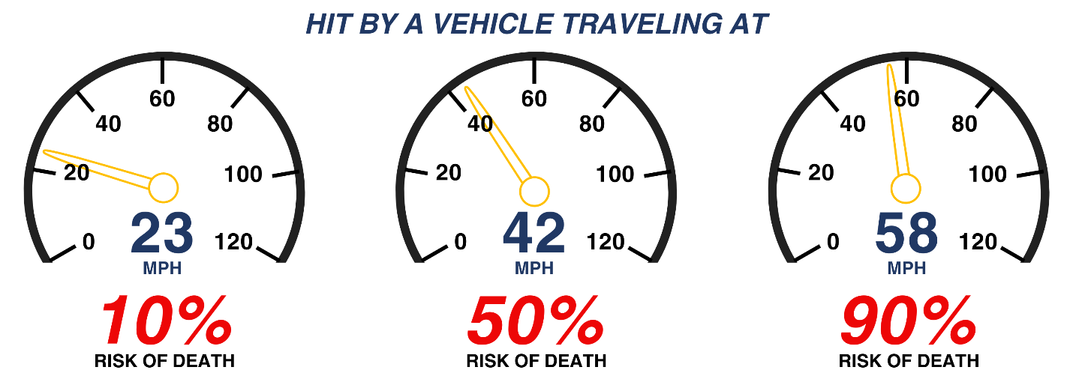
This November 17-21, 2025, <Organization> stands in solidarity with our traffic incident responders and with <Governor/Local Agency Name> who has issued a proclamation designating this week as Crash Responder Safety Week [If your governor or local agency has not issued a proclamation, replace with “the Federal Highway Administration who has issued a proclamation designating…”]. <Organization> is committed to focusing attention on the small, simple actions each of us can take to keep our emergency responders and all road users safe. In observance of Crash Responder Safety Week and its 10-year anniversary, <Organization> reminds all road users that by reducing your speed as you proceed past responders working roadside, you dramatically reduce the risk of death in the event of a secondary crash.

[consider adding a brief paragraph highlighting a local responder struck-by story or statistic, or data on response vehicles out of commission and able to be used for other emergencies]
This Crash Responder Safety Week, <Organization> calls on every road user to:
- Learn, share, and obey our State’s Move Over law. [Highlight your State’s Slow Down law covering how much to slow down and for whom to move over, and link to your State’s Move Over law.]
- Learn, share, and obey our State’s Driver Removal law. [Include if your state has a Driver Removal law, highlight your State’s Slow Down law covering how much to slow down and for whom to move over, and link to your State’s Driver Removal law.]
- Show your support for our traffic incident responders on social media using #CRSW.
This Crash Responder Safety Week, [Organization] also calls on every traffic incident responder to:
- Take the free, four-hour National Traffic Incident Management (TIM) Responder Training available from the Federal Highway Administration to better protect you and your fellow responders.
- Encourage your fellow responders to join the over 800,000 responders that have already completed this training.
- Share on social media the dangers you face when responding to traffic incidents using #CRSW.
[Organization] offers gratitude to our nation’s traffic incident responders who put themselves in harm’s way to keep all road users safe. And we remind every responder and road user, Safety Starts With You –Slow Down and Move Over.

