Final Report

Assessment of automated

Data Collection Technologies
for Calculation of
Commercial Motor Vehicle
Border Crossing Travel
Time Delay

To
Office of Freight Mgt. and Operations
Federal Highway Administration
U.S. Department of Transportation
Washington, DC 20590


April 2002

VERSION 1.0

Assessment of Automated Data Collection

Technologies for Calculation of Commercial Motor

Vehicle Border Crossing Travel Time Delay

by

Battelle
505 King Avenue
Columbus, Ohio 43201

for
U.S. Department of Transportation
Washington D.C.

Contract No. DTFH61-96-C-00077
Task Order 7727

April 2002

Disclaimer

This report is a work prepared for the United States Government by Battelle. In no event shall either the United States Government or Battelle have any responsibility or liability for any consequences of any use, misuse, inability to use, or reliance on the information contained herein, nor does either warrant or otherwise represent in any way the accuracy, adequacy, efficacy, or applicability of the contents hereof.

This report is not intended as a definitive recommendation for a certain ‘best” technology but rather as a guide for further detailed investigation. Its intent is to portray the features of various candidate technologies and relate them to the criteria that need to be met by the application envisioned.

Table of Contents

PREFACE iv

EXECUTIVE SUMMARY v

1.0 INTRODUCTION 1
  - Purpose of the Report 1
  - Organization of the Report 1
  - Background 1
  - Methodology 2

- TECHNICAL APPROACH 2
  - Disadvantages of Manual Collection 2
  - Assumptions and Issues 5
  - Characteristics of the Border Crossings 6
  - Where Would Vehicle Sensing Technologies Be Located? 6
2.5 Overview of Vehicle Sensing Technologies 8
2.6 Candidate Sensing Technologies 9
2.6.1 Automatic Vehicle Identification (AVI) Laser 10
2.6.2 AVI Radio Frequency (RF) 10

RF Tags 11

RF Smart Tags 11

Smart Cards with RF Transponders 11

2.6.3 AVI Infrared (IR) 12

IR Tags 12 IR Tags

Smart cards with IR Transponders 12
2.6.4 Enhanced Common Inductive Loop 12
2.6.5 Signature Inductive Sensors (Enhanced Loop-Based Traffic
Surveillance) 14
2.6.6 Mobile Phone Locating 14
2.6.7 License Plate Readers 16
2.6.8 Vehicle Matching 18

- OTHER CONSIDERATIONS 18
  - Cost 18
  - Maturity of the technologies for deployment 19
  - Site security/vandalism 19
  - Privacy 19
  - Portability 20
  - Hourly count data 20
  - Developments in response to 9/11 21

- TECHNOLOGY TRADE-OFF MATRIX 21

- CONCLUSIONS 22

- REFERENCES 23

APPENDIX A: Trade-Off Comparison of Automated Technologies 25

List of Tables

Table 1 Table 1. Comparison of Vehicle Sensing Technologies 9

Table 2 Summary Matrix of Candidate Sensing Technologies 22

List of Figures

Figure 1. Data Collectors Have To Make Safety the Top Priority 3

Figure 2. The Head of a Queue Can Be Far Away from the Border Crossing 4

Figure 3. Primary on the Mexican Side of the Zaragoza Bridge (El Paso-Juarez) 7

Figure 4. Primary on the U.S. Side of the Zaragoza Bridge (El Paso-Juarez) 7

Figure 5. Some of the Border Crossings Have Large, Imposing Bridges 8

Figure 6. Discharge from Primary Can Be Congested 8

Figure 7. License Plate Reader at the Zaragoza Bridge, El Paso (Automobile Side) 17

PREFACE

Battelle is performing an ITS Program Assessment Support (IPAS) contract for the Federal Highway Administration Office of Freight Management and Operations, under the task “Expansion of Initial Border Measurement Activity – Analysis and Expansion of Sites in 2001.” Specifically, Battelle’s task under this contract is “Evaluation of Travel Time Methods to Support Mobility Performance Monitoring,” contract DTFH61-96-C-00077. Broadly, the task is to collect and compile data on travel time delays experienced by CMVs (commercial motor vehicles, i.e., trucks) crossing the U.S. border to, and from, Canada and Mexico.

Battelle’s contract involves technical support for:

(1) conducting second on-site visits to several international border crossing sites observed in an FY 2000 review of commercial motor vehicle (CMV) travel time, for the purpose of additional collection and analysis of CMV travel data;

nomination of 3 additional crossing sites at Canadian and Mexican borders for evaluation of their CMV travel times;

(3) collection and analysis of FY 2001 CMV travel time data at all 7 crossings; and

(4) incorporation into final analysis of separately collected data at 2 additional international sites that, in 2001, will be concurrently assessing the application of automated border collection and analysis software.

As part of item (4) above, this report evaluates the potential for application of automated monitoring technologies at the sites reviewed in FY 2001 and early FY 2002. These are specific technologies that have promise for automating the collection and determination of CMV (truck) travel times across the U.S. border with Canada and Mexico.

EXECUTIVE SUMMARY

This report describes an evaluation of the benefits and overall potential of technologies that may be used to collect truck travel time data in place of specialized onsite data collectors at border crossings between the U.S. and its neighbors - Mexico and Canada. The report identifies and examines various technologies whose characteristics make them potentially suited to collecting this type of data. In addition, the report also examines their maturity for deployment as well as certain other characteristics that affect their suitability for the intended purpose. The technologies are presented in terms of basic functionality, not detailed specifications. Therefore, the results are intended only as a guide.

The author has chosen to include the assessment of certain technologies that are in a development or prototype stage and thus not yet commercially available, but which have potential for automating the travel time process when developed. Some of the other technologies identified are currently used for other applications but should be capable of being adapted to perform in a manner that should achieve the necessary criteria. This technology assessment focuses principally on sensing technologies, not on the software needed to translate raw data into useful compilations.

No one sensing technology is a clear favorite; each candidate has to be weighed in terms of functionality, cost, concept and length of operations, maturity and availability as well as more mundane considerations like susceptibility to environmental degradation and vandalism.

Any follow-on studies should not be done in isolation from current homeland security concepts being discussed for border crossings. There will probably be very few installations of any of these technologies for the sole purpose of data collection. The technologies discussed in this report should be leveraged with those national security efforts, other federal inspection and trade agency initiatives and local operating efficiency enhancements in a mutually beneficial arrangement.

1.0 INTRODUCTION

  - Purpose of the Report

This report is submitted to assess the potential of certain technologies to determine commercial vehicle travel time at border crossings by automated means.

1.2 Organization of the Report

The technology assessment begins by describing the current method of collecting truck travel time data and calculating delay. Next there is a discussion of the assumptions that underlie the deployment of an automated system. Also discussed are the types of functions that a vehicle sensing technology would have to possess in order to perform effectively in an automated system that replaces some or all of the persons who currently man the data collector functions at a border crossing. This involves examining all of the current vehicle sensing technologies and their features in certain key areas. Then the sensing technologies that possess some of the desired traits will be examined in greater depth. Their basic function as well as advantages and disadvantages will be discussed.

1.3 Background

The FHWA acknowledges, “Our international border crossings are important links in the chain of freight commerce. They are also potential obstacles to efficient movement, imposing delays in response to a number of competing, but necessary Federal and State agency activities, such as immigration status verification, vehicle safety assessments, cargo assessments, drug interdiction, and toll payments.

“To ensure that transportation-related activities can be made less burdensome and facilitate the efficient and expeditious movement of cargoes across our borders, the Office of Freight Management and Operations (HOFM) began, in FY 2000, to collect empirical information about the actual movement of commercial vehicles, traveling from exporting to importing country, at designated crossings along the Mexican and Canadian borders. HOFM’s purpose in FY 2000 was to establish a “baseline” of vehicle travel times at these locations.”

Three border crossings had truck travel time data collected in the FY 2000 effort:
- Otay Mesa, California
- World Trade Bridge, Laredo, Texas
- Calais, Maine

Seven border crossings had truck travel time data collected in the FY 2001 effort:
- Ambassador Bridge, Michigan
- Bluewater Bridge, Michigan
- Peace Bridge, New York
- Zaragoza Bridge, El Paso, Texas
- Blaine, Washington
- Otay Mesa, California*
- World Trade Bridge, Laredo, Texas*

*Otay Mesa and Laredo received data collection on both the FY 2000 and FY 2001 activity.

1.4 Methodology

“Travel time per truck trip” is the measurement chosen to monitor travel time and delay at the border sites. This encompasses the time taken by an individual commercial vehicle from:

- The initial queuing point in the exporting country,
- Through the exporting country’s checkpoint, and
- Up to and through the first inspection point in the importing country.
- Travel in both directions is assessed.

Measurements are taken: (1) at various times during the individual workday and (2) during one or more seasons of the year. “Travel delay” as a measurement is based on an initial determination, at an individual site, of the time required for relatively low volumes of traffic to proceed through the location. Additional measurements are then taken throughout the business day, with special attention to times when significant delays may occur. Data collected at these times are compared to the initial, low volume of activity at the site, and conclusions drawn.

- TECHNICAL APPROACH

2.1 Disadvantages of Manual Collection

The process of getting data collectors onsite and ready to go at a border crossing is detailed and expensive. The collection itself can be physically challenging. There are a number of areas in which automating the process of data collection would offset current disadvantages. Permanent or semi-permanent vehicle sensing technologies, capable of operating in inclement weather, would be an attractive alternative to the current labor-intensive process.

Sovereignty Issues
While Canada and Mexico are friendly nations, getting permission to operate on their soil is not trivial, even with NAFTA. In all cases, data collectors must have the absolute approval of Customs and Immigration. That approval must include provision for being in that nation as well as on the premises of their facilities. Formal, time-consuming paperwork is often required. Any equipment installed in Mexico or Canada would need written approval also, but its continued operation would generally be on a non-recurring basis. Conversely, on-site personnel typically have to have written permission or passes from one or more agencies for each visit.

Other Approvals
Crossings that have bridges may have private authorities, (such as Ambassador Bridge at Detroit-Windsor), who own and operate the bridges and whose approval is required while on their property. Toll operations may be conducted by a national agency (as in Mexico), a city (as in Laredo and El Paso), or an authority (as Ambassador Bridge). Their approval is also required.

A host of additional approvals may be needed, including national or state police, the General Services Administration (GSA) or its equivalent across the border, local municipalities, local law enforcement agencies, and consulates. Even with close communications, data collection can easily get disrupted if knowledge of the agreed arrangements hasn’t reached all the right people in Customs, Immigration, GSA or other on-site organizations. Some of these agencies are large and it is important to ensure that every key person knows what has been orchestrated.

Logistics
In the majority of cases, data collectors have to travel an appreciable distance to reach the site. That involves airfare, rental cars, lodging and meals, labor, shipment of equipment, and sometimes out-of-country auto insurance.

Safety
While this has not been a problem to date, there is no question that operating in the vicinity of a stream of tractor-trailers whose drivers are on tight deadlines requires collectors to be constantly aware of their surroundings. A secondary issue is personal security. While data collectors are generally in the vicinity of Customs operations, some may have to venture to remote locations to stay ahead of a queue. This situation can introduce new and unexpected traffic conditions. Or the collector may find that the area does not appear to be in a particularly safe neighborhood.

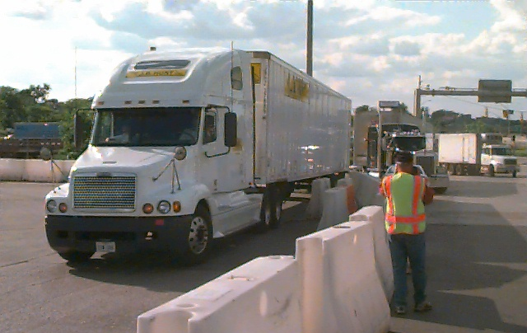

Figure 1. Data Collectors Have To Make Safety the Top Priority

Weather
Temperatures along the Mexican border can easily top 100 degrees F. The Canadian border can be hot as well, but rain – particularly in conjunction with cool temperatures – can be challenging to the data collector on the Canadian border. Of course, the Canadian crossings have very cold temperatures during the winter months, but ice and snow would affect many of the sensing technologies as well. Some of the collection points experience high winds, and the data collectors may be exposed to wind-driven grit generated by passing trucks. In fact, data collectors in El Paso experienced dust storms at the Zaragoza Bridge crossing at El Paso-Juarez during the 2001 truck travel study, at which time visibility dropped rapidly. The effectiveness of sensing technologies can also be reduced by weather, particularly fog, ice, and snow.

Limited collection times
Data collectors must arrive at pre-determined times. The process of scheduling those times must take into consideration national holidays on both sides of the border. It must identify the periods that are most conducive to actual collection of limited data. It must ensure that all necessary approvals have been secured and word is out. Said another way, there is pressure to ensure that quite a number of “moving pieces” come together as planned so as to maximize the results possible during this limited period. Any disruptions at this point, whatever their nature, must be responded to aggressively.

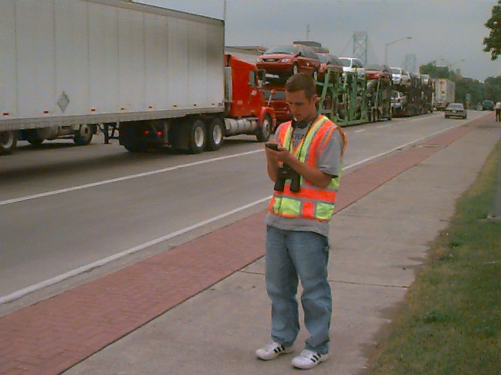

Figure 2. The Head of a Queue Can Be Far Away from the Border Crossing

2.2 Assumptions and Issues

The essential function that any candidate sensing technology must possess is the ability to collect data that allows measurement of truck travel time and, consequently, delay. A number of technologies exist – or soon will – that can use a variety of approaches to accomplish that same objective. However, there is a key challenge that confronts most of the technologies that could potentially be used in the methodology. That challenge is the need to have paired upstream and downstream collectors - in the same traffic flow direction - located in different countries. For the technologies that require onsite infrastructure to accomplish that, sensing technologies will need to be in Canada or Mexico in order to yield the paired data needed for matching. There is only one technology type that would not require such infrastructure: mobile phone locating, discussed in section 2.6.3.

Two important features that a successful sensing technology used for this application must possess are the ability to (1) identify a specific truck with a high degree of accuracy (i.e., 75% or greater), and (2) record an individual truck with a high degree of geolocation accuracy. That accuracy is assured with the technologies that have sensing technologies situated at specific locations, but it is currently more difficult to obtain with mobile phone locating.

It is not necessary that a sensing technology be able to capture every vehicle for the purposes of travel time data collection. It may, however, be an important requirement for inspection, tolling or other cooperative uses. That is not practical with the current manual data collection techniques, nor is there any compelling argument for an automated system to capture 100 percent of the vehicles especially if doing so results in higher costs. Total capture would be a useful feature but not essential.

This might mean that sensor hardware could be mounted to read vehicles in one of two or more lanes, assuming that there is no characteristic of the facility’s geographic layout that results in any appreciable difference between the lanes. However, a collateral feature that is desirable is the ability of the sensing technology to yield the hourly crossing data, which has been difficult to get for both directions of travel at some border crossings.

If a sensing technology requires infrastructure, then ideally the sensing technologies will be mounted in similar – or comparable - configurations on both sides of a border crossing, for consistency. Obviously, any such arrangement will have to be worked out with Mexico or Canada. It is not often that the U.S. government purchases and arranges installation of hardware across the border, although that has reportedly been done.

Undoubtedly, there could be sensitivity to that issue unless it was clear that it is expressly for traffic measurement or if the technology is part of an operations improvement program for inspection and other purposes. There might be many benefits that accrue to Mexican or Canadian Customs, such as providing hourly counts, communicating trade information or toll charges. The USDOT data needs can be integrated into the information being communicated.

The license plate readers and vehicle matching technologies are sensing technologies that require infrastructure and have portable options. However, these portable options are quite expensive, costing tens of thousands of dollars per lane, and these platforms may have problems with vandalism if remotely located. It is difficult to align the portable license plate readers in a manner that equals the effectiveness of a hard-mounted reader.

2.3 Characteristics of the Border Crossings

Traffic flow measurements at the border crossings vary as a result of season, day, time of day, number of booths manned by Customs personnel, and additional security measures in effect (particularly after 9/11). When there is no congestion at primary or upstream of it, then the flow rate (trucks per hour) is equal to the existing demand (the amount of traffic volume that results at a facility under some set of travel conditions). This situation typically occurs when a crossing opens after being closed for a night or before any traffic starts to build up. It is used in the calculation for “travel time with no delay.” If a queue exists at the border crossing, then the measured flow rate reflects the downstream bottleneck capacity; thus, actual measured flow rates would be less than the demand. Delay is measured in terms of flow rate and travel time in excess of the free-flow value.

2.4 Where Would Sensors Be Located?

For a technology that requires on-site infrastructure to replace data collectors, two sensing technologies will be needed for each direction of flow. The first sensor needs to be located in the exporting country upstream from the entry point into the Customs facility, generally just beyond the point to which queues ordinarily extend. Ideally, this would be in a location that all inbound trucks must pass (in other words, there are no other routes that could feed trucks into the queue downstream from this point).

The second sensor needs to be a short distance downstream from primary (in the importing country). Currently, downstream data collectors are stationed within approximately 180 feet from the booths at the primary checkpoint. The sensing technologies could perhaps be located where trucks leaving from the bank of (up to ten) primary booths could be funneled into fewer lanes, for technical considerations or reasons of economy.

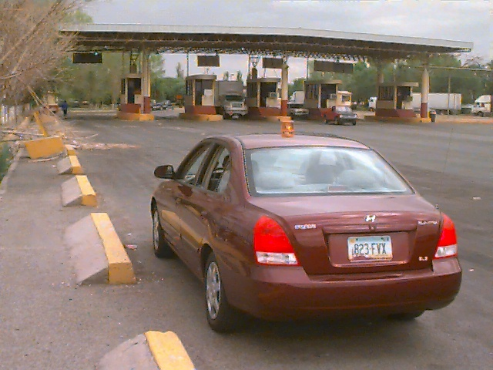

Figure 3. Primary on the Mexican Side of the Zaragoza Bridge (El Paso-Juarez)

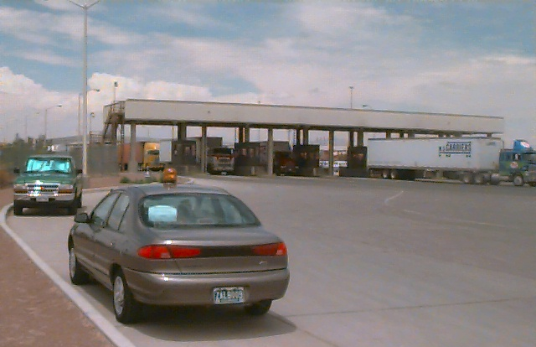

Figure 4. Primary on the U.S. Side of the Zaragoza Bridge (El Paso-Juarez)

Any radio frequency (RF) communications that are short-range or line-of sight would not work well at some locations, particularly the ones at which there are long bridges or a lot of steel mass (see figures 5 and 6).

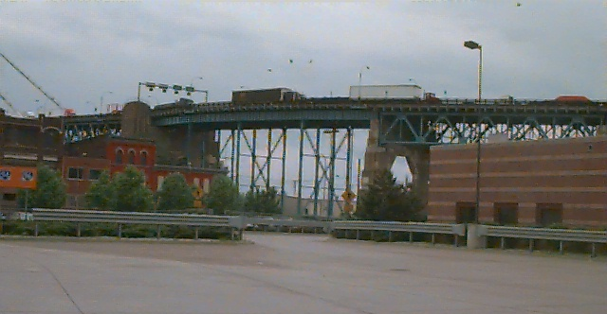

Figure 5. Some of the Border Crossings Have Large, Imposing Bridges
(Shown: the Ambassador Bridge, Detroit-Windsor)

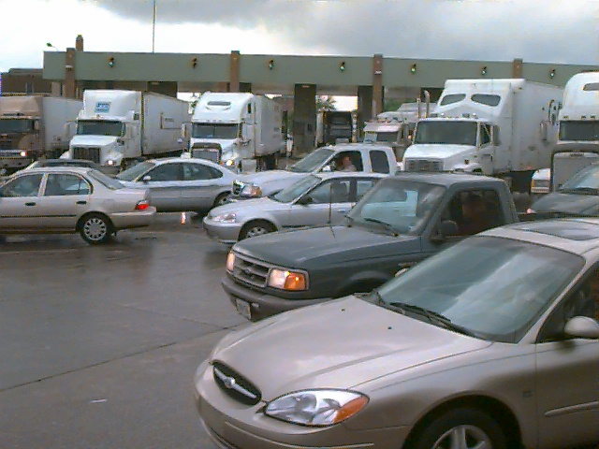

Figure 6. Discharge from Primary Can Be Congested
(Shown: Canadian side of Ambassador Bridge, Detroit-Windsor)

2.5 Overview of Vehicle Sensing Technologies

Table 1 lists vehicle sensing technology types and examines a number of characteristics that would factor into their individual suitability for the intended purpose of travel time calculation. The top-level characteristics of each are then discussed.

2.6 Candidate Sensing Technologies

To be a candidate for the short list of this study’s trade-off study, a sensing technology must be able to:
- make positive identification of both inbound and outbound trucks at a matched pair of two points (upstream and downstream) that correspond to where data collectors are currently stationed for manual readings;
- time-stamp each vehicle that is positively identified at its detected location so as to enable travel time calculations, and;
- operate in all weather conditions found at a border crossing.

Table 1. Comparison of Vehicle Sensing Technologies

Technology | Travel Time  S/W | Low Volume Count | Not Privacy Invasive | Inclement Weather | Low Infra Cost | Positive ID
Ultrasonic |  |  | Yes |  | Yes
Microwave Doppler |  | Yes | Yes | Yes | Yes
Microwave True Presence |  | Yes | Yes | Yes | Yes
Passive Infrared |  |  | Yes
Active Infrared |  |  | Yes
Visible VIP |  | Yes
Infrared VIP
Acoustic Array |  |  | Yes
SPVD Magnetometer |  | Yes | Yes | Yes | Yes
AVI Laser |  |  |  |  | Yes | Yes
AVI RF Active Tags |  |  |  | Yes |  | Yes
AVI RF Passive Tags |  |  |  | Yes | Yes | Yes
AVI RF Smart Tags |  |  |  | Yes |  | Yes
AVI Smart Cards with RF Transponders | Yes |  |  | Yes |  | Yes
AVI IR Tags |  |  |  | Yes | Yes | Yes
AVI Smart Cards with IR Transponders |  |  |  | Yes |  | Yes
Enhanced Common Inductive Loop |  | Yes | Yes | Yes | Yes | Yes
Signature Inductive Sensors (Enhanced Loop-Based Traffic Surveillance) |  | Yes | Yes | Yes | Yes | Yes
Mobile Phone Locating |  |  |  | Yes | Yes | Yes
License Plate Reader |  | Yes |  | Yes |  | Yes
Vehicle Matching System | Yes | Yes |  | Yes |  | Yes
The sensing technology types in Table 1 that meet these essential criteria are examined in greater detail below. A ‘Yes” entry in Table 1 indicates a positive trait. A candidate sensing technology would ideally also be:
- inexpensive to purchase, install, and maintain;
- not easily vandalized;
- not seen as invasive of privacy by its users;
- capable of use without installation outside the U.S. border;
- able to count all vehicles that pass (as a collateral benefit to the overall border
crossing truck travel time program); and
- communicate information (or connect to a computer that will) for other purposes
(toll, Customs, etc).

None of the technologies that are examined below has all of the desired attributes. Furthermore, the only technologies in this list that are currently known to already have software for calculating travel times are the Automatic Vehicle Identification technologies (used for electronic toll collection) and the Vehicle Matching System (which is being used in Europe). However, development of software to work with any of these sensing technology types should be possible without great expense.

Automatic Vehicle Identification (AVI) refers to the components and processes of a toll collection system in which the equipment is able to determine ownership of the vehicle in order to charge a toll to the proper customer. AVI technology is broken down into three main categories: Laser, Radio Frequency (RF), and Infrared (IR).

    - Automatic Vehicle Identification (AVI) Laser

AVI Laser systems read a bar code attached to a vehicle, which is read by a laser scanner as a vehicle passes through a toll lane. This technology is susceptible to weather and dirt. Also, the barcode must be reasonably close to its reader, which reduces the distance over which this system can work.

    - AVI Radio Frequency (RF)

AVI RF systems utilize a transponder tag that is read by an RF reader/antenna. Some RF tags are used for vehicle-to-roadside communications, which can be used to inform the driver of traffic conditions. RF technologies include RF tags, RF smart tags, and smart cards with RFR transponders.

An RF tag is a device located in or on the vehicle that is used in conjunction with an in-lane RF antenna to communicate identifying information about the vehicle and customer to the toll system. The information stored in the tag is fixed (read only) and cannot be changed. The RF tag does not have any processing capability. This type of tag is referred to as a Type I tag. Some tags have an updateable (read/write) area on which an antenna/reader may encode information such as point of entry, date/time of entry, etc.

A RF tag operates in a half duplex mode, which means that it cannot send and receive data at the same time. The signal that it uses can be generated in one of two ways: actively (in which the RF tag contains a transmitter and generates its own RF signal) and passively (in which the RF tag modifies and reflects the signal it received from the antenna/reader. A passive RF tag does not contain a transmitter).

An RF smart tag is an RF device located in the vehicle that is used in conjunction with an in-lane RF antenna/reader to communicate identifying information about the vehicle, customer, and account balance to the toll system. Some portions of the tag information are fixed (such as vehicle and customer data) while others are updateable (such as account information). The smart tag contains a microprocessor which is updated each time the smart tag is used. RF smart tags operate in full duplex mode, meaning that they are able to send and receive data at the same time. They actively generate the signal used to communicate with the antenna/receiver via a transmitter.

The smart card with RF transponder is an integrated circuit device that contains a microprocessor and memory and stores account balance information. For toll collection, smart card use requires the smart card itself and a separate RF transponder (tag). The RF transponder is a device located in the vehicle that interfaces to the smart card and allows the smart card to communicate with the in-lane antenna/reader. In addition, the transponder contains information about the vehicle that it transmits to the antenna/reader along with the smart card information. The tags used with smart cards employ either full or half duplex communications with active or passive transmissions.

The toll operation at the World Trade Bridge near Laredo, Texas utilizes smart cards with RF transponders to collect tolls for around 95 per cent of outbound trucks (i.e., trucks leaving the U.S. for Mexico). There is an associated weigh-in-motion sensor that helps the toll agency charge by axle and weight. The weigh-in-motion sensor cable is located approximately 150 feet from the entrance to the truck tollbooths and extends across all eight lanes. This is the only smart card/transponder arrangement on the Mexican border, and it might present a great opportunity for a pilot test.

With this type of system, each toll lane is equipped with an RF antenna that is usually mounted in the center of the lane above the roadway. The reader sends out a signal via the antenna to the tag that lets the tag know that it should begin communication. The tag returns a unique ID number that is used to identify the vehicle (customer) to the electronic toll collection (ETC) system. In the case of read/write tags, smart tags, or smart cards with an RF transponder, the tag may transmit additional information such as account balance or point of entry and the reader may send back updated information to be encoded on the tag/smart card. The maximum read/write range of RF tags is generally up to about 100 feet. In use, they are usually within 20 to 30 feet of the antenna during communication.

Advantages of AVI RF sensor technologies include proven technology and relatively low cost. Disadvantages include infrastructure costs and the need for cross-border operational agreements.

2.6.3 AVI Infrared (IR)

AVI IR systems utilize an in-vehicle tag that is read by a reader/transmitter installed in the toll lane. IR technologies include IR tags and smart cards with IR tags. An IR tag – similar to an RF tag - is a device located in or on the vehicle that is used in conjunction with an in-lane IR antenna to communicate identifying information about the vehicle and customer to the toll system. The information stored in the tag is fixed (read only) and cannot be changed. The IR tag does not have any processing capability.

A smart card with IR tag essentially operates in the same functional manner as a smart card with RF tag – the key difference is its method of communication (an IR vs. an RF frequency). AVI Infrared technologies have much the same basic advantages and disadvantages as AVI RF technologies.

Border Applications of Automatic Vehicle Identification Technology
AVI RF and Infrared advantages include proven technology and moderate cost. Disadvantages include infrastructure costs, some susceptibility to environmental influences, and the need for cross-border operational agreements.

    - Enhanced Common Inductive Loop

Loop detectors, are the primary source of quantitative traffic data in the U.S. They are usually hexagon-shaped wires buried in the road. When a vehicle passes over a loop detector, its metallic mass causes fluctuations in the detector’s inductance. Until recently, the cards used with loop inductors only read in a pulse or a presence mode, which produced a digital output. Using this technology, when the measured inductance crossed a threshold set in the detector card, its field controller read it as a digital “one,” or occupancy. When the vehicle moved off of the detector, the field controller then read a digital “zero,” or unoccupied. This technology did not differentiate for the size of vehicle.

The principal components of an inductive loop detector are one or more turns of insulated wire buried in a shallow cutout in the roadway, a lead-in cable that runs from a roadside pull box to the controller, and an electronics unit located in the controller cabinet. The insulated wire loop can be excited with a signal ranging in frequency from 10 KHz to 200 KHz and functions as an inductive element in conjunction with the electronics unit. The disadvantages of the basic inductive loop technology include:
- time and difficulty of installation (involving up to a dozen saw cuts),
- fitting the loop to the cuts without crimping or nicks,
- changes to inductance caused by the environment,
- vehicle’s offset in a lane, which adversely affects repeatability,
- vehicles with large differences in inductance, and
- vehicles changing lanes.

Data supplied by these loop detectors are vehicle presence, count, and occupancy. When used in pairs to form a “speed trap,” they can also measure speed directly. Two loops placed close together in this way gauge vehicle speed based on the time between occupancy of the two sensors. Speed and occupancy can be used to determine a vehicle’s length. When a vehicle stops on or passes over the loop, its inductance is decreased indicating the presence or passage of a vehicle. The electronics unit responds to the change in inductance and conveys the vehicle presence data to the controller when requested. This basic inductive loop technology was developed in the 1970’s and ‘80’s and did not change much until recently.

However, there are now loop detectors that have the capability to produce a vehicle inductive signature through a serial port on the detector card. This unique signature results from the net decrease in the detector’s inductance when the metallic mass of a vehicle passes over the magnetic field generated by the inductive loop. Inductive signature analysis can allow vehicle classification data to be derived. In other words, instead of knowing that some vehicle of indeterminate size passed over the detector, the characteristics of the signature can be used to determine whether, for example, the vehicle was a passenger car or a large truck.

The California Partners for Advanced Transit and Highways (PATH) has conducted much research into this new technology. PATH took a three-phased approach to improving this technology. First, they used existing loop detector hardware but upgraded the communication protocols and analysis software. The second phase replaced existing loop detector cards with commercial detector cards capable of outputting a vehicle’s inductive signature. This approach not only permits most vehicles to be matched, it also gives more accuracy to local counts and vehicle classifications. It can offset many detector failures by automatically adapting to changes in loop inductance. Finally, that ability helps to improve a number of current reliability problems that exist with inductive loop technology. PATH’s third phase intends to use more advanced detector hardware and simpler, cheaper, more reliable loop geometries.

There are two different systems that have been developed for classifying vehicle signatures. One system uses a Self-Organizing Feature Map, which is an artificial neural network. On a test, this technology was said to have been able to classify 300 test vehicles with an accuracy of 85 percent (the classes involved were SUV, limousine, bus truck, car towing trailer, and semi-trailer truck). A second system uses, for classification, a heuristic discriminant algorithm. This approach was said to yield 81%-91% overall classification rates in testing.

With these accuracies, inductive signatures can be applied to some new transportation measures. Data can be derived that were not previously accessible, including section travel time. Speeds that previously derived from double inductive loop configurations can now be derived with single loops by using vehicle inductive signatures. Thus, there are new ways to collect important real-time data through the use of inductive signatures. There are a number of new applications that emerge from this improved technology that are beyond the purpose of this report.

Border Applications of Automatic Vehicle identification Technology
Among their advantages, loop detectors are a common, recognizable sensor. They have relatively inexpensive purchase and installation costs. One of their disadvantages is that where crossing vehicles are mostly similar (i.e., large trucks), differentiation will be more difficult than if there are more diverse vehicle types in the traffic flow. How accurately this enhanced loop-detection system can positively identify a specific truck among a throng of other trucks remains to be seen, so therefore it is a potential drawback.

2.6.5 Signature Inductive Sensors (Enhanced Loop-Based Traffic Surveillance)

One company interviewed in conjunction with this report had an inductive signature product under development. Their product feature claims include:
- single roadway cut installation, which can cover multiple lanes and covers lane edge to lane edge;
- faster, safer, and easier installation (approximately ½ hour vs. 4 hours);
- shorter traffic stoppage/impedance times, with minimal travel time loss;
- more defined signature data;
- uniform data over entire lane of traffic, regardless of vehicle lateral offset within the lane; and
- does not miss turning or off-center vehicles like other loop technologies.

Border Applications of Automatic Vehicle Identification Technology
The same advantages and disadvantages that applied to the previous category – enhanced common inductive loop – apply to signature inductive sensors as well. However, this technology is intended to produce better discrimination among vehicles.

2.6.6 Mobile Phone Locating

A recent study has found that 49.5 percent of cellular phone calls were placed while driving. While the percentage of wireless calls placed by drivers - compared to those placed in home or office - has declined somewhat, the number of such calls has grown considerably. There are now said to be nearly 120 million wireless subscribers in the U.S. The popularity of cell phone use has given rise to surveillance technology that uses geolocation of those callers.

The CAPITAL (Cellular Applied to ITS Tracking and Location) Operational Test and Demonstration Program, which was conducted in 1994 in the Washington, D.C. metropolitan region, was one of the first actual field deployments of technology to geolocate cell phone calls. This ITS operational test made extensive use of the existing cellular infrastructure for both area wide surveillance and communications. Equipment was co-located on Bell Atlantic mobile towers to detect cellular users and geolocate phones on designated roadways. The project explored questions related to positioning accuracy, incident detection accuracy, possible applications in a traffic management center (TMC), and potential for replacing or supplementing certain other technologies, such as loop detectors and video surveillance. The CAPITAL operational test represented a first-generation approach to geolocation. It utilized RF direction finding and required substantial infrastructure, and it required both line of sight and multiple cell towers to function.

In the years since the CAPITAL project demonstrated some of the attractive features of geolocation, the technology has advanced. “New modes of cellular geolocation are available. The installed base of cellular telephones is far greater, and includes a wider variety of cellular protocols, both digital and analog. This affords the opportunity to focus more directly on transportation management issues, such as the accuracy of speed estimates derived from dynamic geolocation measurements, applications to incident detection and management, and cost-benefit analysis.”

Consequently, another mobile call tracking prototype system is currently being tested in the Washington, D.C. metropolitan region. This ITS operational test is the Capital Wireless Integrated Network (CapWIN). Following along the same lines as the CAPITAL project, it implements a wireless communications network that serves the core mobile communication functional needs of transportation, law enforcement, fire and EMS in the Washington metropolitan region. Its network supports multiple in-vehicle platforms.

Something that has advanced location services is Emergency 911 (or E-911) calls for emergency assistance. As part of the Federal Communications Commission’s E-911 mandate, all cellular service providers must be able to accurately estimate the location of incoming wireless Emergency 911 calls by October 2001. Part of that requirement is that wireless service providers have the ability to pinpoint and report to Public Safety Answering Points (PSAPs) the locations of all 911 callers within an accuracy of 100 meters in 67% of all cases.

In response to this need, a company participating in the CapWIN operational test has developed a technology that allows cellular phone calls to be tracked and monitored anonymously. The proprietary Location Pattern Matching process used by this system determines a wireless subscriber’s location by measuring the distinct RF patterns and multi-path characteristics of radio signals arriving at a cell site from a caller. The technology identifies the unique radio frequency pattern or “signature” of the call and matches it with a similar pattern stored in a central database. This system does not require direct line of sight to multiple base stations to identify locations. Since this system can use its own antenna arrays to detect RF signals, no alteration to existing cellular base stations or subscribers’ handsets is required.

In operation, “a mobile phone placing a call emits radio signals. The signals bounce off buildings and other obstacles, reaching their destination (the base unit) via multiple paths. At the base station, the (technology) analyzes the unique characteristics of the signal, including its “multipath” pattern, and compiles a ‘signature.’ The signature pattern is compared to a database of previously identified signature patterns and their corresponding locations, and a match is made. By matching the signature pattern of the caller’s signal with the database of known signatures, the caller’s geographic location is identified and mapped. By continually updating the location data for multiple callers on a specified road segment, the speed at that segment of roadway is computed algorithmically. Speed data (are) stored in a permanent database that permits historical analysis of traffic flow for Traffic Management. Additionally, a transient database is available for real-time display of traffic flow.” The system consists of a base unit and a location pattern-matching database. It requires only one cell site in an area to function, which means it is also suited to rural sites where some of the border crossings are located.

The literature of the company providing the location pattern matching technology states, “Unlike other location technologies under development, (its) technology eliminates the need for line of sight triangulation involving multiple cell sites. This is particularly important in dense urban environments where buildings tend to obstruct the line of sight, and in sparse rural environments where it is unlikely that three or more base stations will be available to receive the caller’s signal.” The company notes, “more than 70% of the wireless population currently resides” in those same dense urban environments.
It states that its system “adapts to existing cellular infrastructure and requires no alteration to the base station or subscriber handsets. Subscribers will not need to purchase new phones to access services, and wireless carriers will not need to make expensive infrastructure investments to offer location-based services.” And “information generated by each (of this system’s) Base Unit(s) is downloaded to centralized database hubs, which route the geolocation information to Public Safety Answering Points (PSAPs) and other service providers or call centers.”

Another company uses a related but different approach that derives traffic information from the routine operational data of cellular telephone networks - an approach that requires no field hardware devices. This approach uses mobile phone data that come from multiple wireless carriers, whose cellular signal data are married with other ITS data and GIS data. This company asserts that their technology uses advanced-intelligence software to determine average vehicle speeds, real-time traffic patterns, and velocity data to determine roadway conditions. They say that it can deliver that information in real time to Traffic Management Centers. And in areas with insufficient volume to determine traffic data, they utilize wireless bandwidth on a limited basis. This data has been stripped of any customer identity information.

Border Applications of Automatic Vehicle Identification Technology
The key advantage to mobile phone locating is that it requires no new infrastructure. Disadvantages include the dependency on drivers making calls in sufficient numbers while crossing, from before the first data collection point through the second. Also, origin/destination geolocation capability from mobile phone locating is not currently as accurate as on-site sensors. Whether that accuracy difference is significant is not currently known.

2.6.7 License Plate Readers (LPRs)

There are many license plate readers already in use at border crossings at both Mexico and Canada. Both the U.S. and Canada utilize them at Customs booths for automobiles. None are currently being used for trucks. They are purchased from the same company and used in the same manner. These license plate readers are used to record the arrival and departure of vehicles at the U.S.-Mexico border. This system works by electronically recording the front and rear plates of vehicles as they pass through the port. The system then digitizes the information and sends it to a Customs information database.

A computer checks a national database of stolen cars to see if the plate numbers match. The computer then alerts Customs officials if the car was stolen or used in criminal activity. This LPR system reads and recognizes violators’ license plate numbers within milliseconds. The initial installations focused on first getting LPRs installed for the lanes inbound from Mexico but law enforcement officers would like to have the systems in both inbound and outbound lanes.

A license plate reader converts image patterns into previously learned symbols prior to comparison. Slowly-moving vehicles can pose a greater challenge to the LPRs because they are more capable of making turning movements within the sensor’s focus.

Border Applications of Automatic Vehicle Identification Technology
Advantages include a relatively high positive identification rate and the fact that many LPRs are already in use at Customs facilities, both in the U.S. and Canada (see figure 7). A portable option is available, but its portability does not give it as much accuracy as the hardmounted version. Among the disadvantages, many trucks have multiple license plates that would confuse the reader, or dirty, damaged, or bent-over license plates that are more difficult to read. And the portable devices would be susceptible to vandalism if remote from Customs or toll operations facilities. LPRs would be a relatively expensive system for a travel time application.

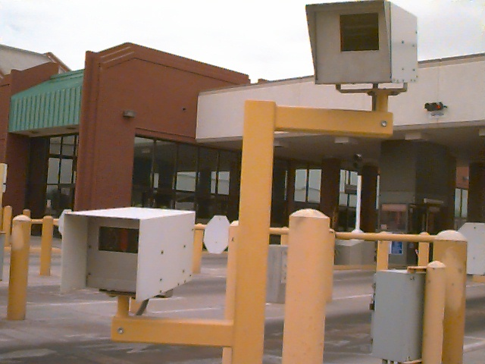

Figure 7. License Plate Reader at the Zaragoza Bridge, El Paso (Automobile Side)

2.6.8 Vehicle Matching

A vehicle matching system compares image patterns directly without the requirement to recognize symbols. This means that it does not “read” a license plate. It works by capturing the images of passing vehicles and “fingerprinting” each vehicle together with a date, time, and position stamp. A communications link transmits these fingerprints to an exit system, which stores them as entry fingerprints. The exit system also captures vehicle images and creates fingerprints, then matches them. This technique is used to determine travel time of vehicles that have been speeding, and then activates a license plate reader to document the violation and bill the vehicle owner.

A company that provides this technology claims that it:
- will work with any license plate style or type;
- does not need to be re-programmed if new plates are issued;
- is not affected by trailer hitches, license plate frames, etc.;
- uses more information than just plate characters;
- can perform matches on vehicles without visible license plates; and
- works whether the vehicle has a computer-readable license plate or not.

This product uses a laser ranger to detect passing vehicles, which triggers a camera. Vehicle images are captured by this advanced digital video camera, whose controls are constantly adjusted by a smart light sensor. This light sensor adjusts camera parameters for optimum license plate and vehicle contrast regardless of ambient illumination conditions. It decides when to turn nighttime illumination on or off. It uses a light flash that is filtered to be invisible to drivers and which illuminates the entire vehicle, not just the license plate.

Border Applications of Automatic Vehicle Identification Technology
Among the advantages, there is a very high probability of identification. There is also a portable version of this system available. It involves a trailer that positions an arm with the sensing technology equipment over two lanes of traffic. However, the portable version ideally needs a downlook angle from overhead to fingerprint moving trucks effectively. Among the disadvantages, Vehicle Matching would be a relatively expensive system for a travel time application.

- OTHER CONSIDERATIONS

3.1 Cost

The cost of a system that automates the detection of trucks and the calculation of their travel time must take into account that the information it derives might be part of a larger, more detailed information-providing system and that the continuous data might be more valuable than sporadic visits. The costs of an automated system must therefore be measured against the recurring and non-recurring costs from having a team of data collectors travel to a site for one, or perhaps two, data collection cycles per year. Rather, the automated system (depending upon the configuration chosen) could yield data on an hourly basis for every day of operation throughout the year. The value of that data must be weighed against the system cost on some type of amortization schedule.

The opportunities to leverage concurrent use of technologies that emerge from local, state, and federal uses as well as from the response to the terrorist threat should be a key part of any deployment. In fact, it may be appropriate to study the operating, trade, and security-related technologies that are being considered in terms of potential dual-use technology.

3.2 Maturity of the technologies for deployment

Any of the technologies in Table 2 could probably be made to work in the application of vehicle identification and travel time calculation. Most would require some non-recurring effort to design software for those applications. Most of the candidate technologies are mature in at least a related use. Some are still being developed but appear to be well along the path to achieving reliable results in the field.

3.3 Site security/vandalism

Equipment security is a concern. Should equipment be located outside of Customs property, whether permanently mounted or portable, it may be subject to theft or vandalism. For example, this would be a concern if a sensor were located well upstream in the flow of traffic due to a long queue. That is currently the situation as increased security concerns are causing delays at the border crossings for all vehicles.

3.4 Privacy

Many recent articles have dealt with the issue of privacy and commuters. There is a transportation system in New York that tracks cars that have electronic tollbooth tags, to help gauge speeds and congestion. In the Washington area, an ITS project (section 2.6.6 above refers) allows transportation officials to monitor movement of drivers talking on cell phones. There is even equipment that “sniffs” passing cars to identify which radio stations motorists have chosen.

Combined with the September 11 terrorist attacks, there is understandably increased interest by government organizations in what members of society are doing. Some of the same technologies that help us respond to incidents and manage congestion can reveal information about the driver. One example is the use of cameras to snap photos of cars that run red lights, and there are sites where cars that are out of standards for emissions are photographed automatically. Closed circuit television cameras are increasingly used to monitor roads; as their resolution gradually improves, they could be used to automatically match vehicle occupants’ faces to reference databases. (Note: some uses of the technologies above have been legally – and successfully – challenged). Some on-board navigation systems allow vehicles to be tracked. The mobile phone location matching discussed above takes care to remove any identification of the driver, but many drivers are aware that such a system is tracking their vehicle. Law enforcement authorities at many border crossings in fact, use the license plate readers that are also discussed above, for the principal purpose of identifying lawbreakers attempting to cross.

For all of these reasons, truck drivers may feel anxiety about a visible automated technology, particularly when it first appears. Government organizations like Customs or toll operations may find it prudent to get acknowledgement from unions or trucking associations of any automated technology used to determine travel time. Those groups may need to be reassured that the technologies are not an attempt to identify, conduct surveillance, or otherwise invade the privacy of the truckers who are their members. In the current climate, there will be a natural tendency to suspect that any new technology has something to do with security.

  - Portability

For some types of devices, portability offers advantages if equipment were truly “plug-and-play.” If automated sensing was not needed full-time, the equipment could be used temporarily then moved to another site. However, not all technical approaches have infrastructure that fall into this category. Even with those that do, the sensitivity of the equipment may not reasonably lend itself to any approach beside a permanent installation. And security is also a concern.

  - Hourly count data

Due to the difficulty that Battelle and others have experienced getting hourly truck travel information from some crossings, particularly from the Mexican side, it would be useful to collect ongoing hourly counts. Some of the sensing technologies like the signature inductive have the capability to count vehicles. Without this inherent capability in the technology, it may be desirable to set up “semi-permanent” inductive loops or pneumatic tubes at the crossings to count hourly traffic. Ideally these would be at the same locations on both sides of the border, for example around the tollbooths (where traffic outbound from the U.S. is tabulated, although not all crossings have toll operations).

However, recognizing that other national governments would be involved, these loops or pneumatic tubes could all be on the U.S. Customs side of a crossing for expediency. If that approach is taken, however, there would be errors in comparing outbound and inbound travel that are induced by positional differences. Since the pneumatic tubes would all have to be on the same side of the border, they would not be not at the same upstream-downstream positioning as the ideal tollbooth–primary inspection pairing. But the error would perhaps not be significant for the purpose intended: determining patterns.

  - Developments Since 9/11

Following the terrorist attacks in New York and Washington, additional security measures at the border crossings resulted in delays that produced significantly longer travel times, particularly for traffic inbound to the U.S. Work-around measures were implemented to alleviate the congestion created, recognizing the detrimental effect that the condition was having on trade. A December 18, 2001 article in the El Paso Times discussed a homeland security approach being considered that could perhaps affect the selection of a technology to automate truck travel time determination.

“Under the coordinated agenda, truck drivers, motorists, and pedestrians would be issued ‘Smart Cards,’ which have been mainly used by commuter lane traffic. The cards contain biometric information and photo images, which can be checked in seconds by computer and verified by port officials. In addition to the cards, scanners - 12 for trucks and vehicles - would be used to peer into semi trucks as well as into autos to examine their contents. At least 20 scanners would be used to check motorists and pedestrians.”
“…..the Ysleta (note: also known as the Zaragoza) port of entry in far east El Paso is the second largest in the state.” “…it would cost about $18 million to outfit the (Ysleta/Zaragoza) crossing with personnel, scanners, and other high-tech equipment.”

As mentioned in section 2, smart cards with RF transponders are already used by most of the truck drivers passing through the tollbooths of the World Trade Bridge border crossing to pay tolls as they leave the U.S. If these newer smart cards with biometric information are used at all border crossings, they could in theory be adapted to support toll collection as well as register a timestamp through recording equipment. If so - and if Customs agencies support the idea – such smart cards might be the technology of choice for automating the truck travel time process. Of course, there would need to be an agreement with Mexico and Canada to allow equipment to be installed in order to read both points in a matched pair of sectional travel locations.

- TRADE-OFF MATRIX

The sensing technologies delineated in Table 1 that appear to meet the essential operational criteria of positive identification in a matched pair of collection points, time-stamping, and all-weather operation, are compared in Table 2. This assessment assumes that any of the technologies in Table 2 will perform technically in an acceptable manner and that software with which to calculate travel time can be developed (if it is not already in use for that purpose). The format is a stoplight chart that makes subjective judgments about how nearly the sensing technology meets the ideal.

A green circle indicates the best category of performance in a particular category. A red square may indicate the least amount of performance in that category or it may mean inability to perform in that category, depending on the context. Red, for example, does not indicate a show-stopping inability that would preclude the use of that particular technology but rather a relative perspective of how it compares to the other technologies compared to cost, convenience, or collateral features. Thus, some red in a given row does not signify that the technology cannot be expected to perform in that application. There is no technology listed in Table 2 that does not have some red. A yellow triangle signifies an intermediate position; for example, it may indicate progress toward meeting a need but something short of a mature technology for the application.

Table 2 therefore focuses more on practical aspects of a limited number of sensing technologies, any one of which should be able to perform the functions required. The comparison assumes that AVI technologies (e.g., smart cards with RF transponders) are not used with all vehicles. Likewise, not all drivers will be using their cell phones as they cross the border. As the Table 2 footnote 1 explains, two of the categories have no intermediate positions: a technology either fits the category or it doesn’t.

Table 2. Summary Matrix of Candidate Sensing Technologies

Technology | Geolocation/  Travel Time  Accuracy | % of Vehicles Recorded | Cross-Border Installation  Required1 | Mature Technology for  Application | Infra-struct.  Cost | Total  Hourly  Count2
AVI Laser
AVI RF tags
AVI RF Smart Tags
AVI Smart Cards with RF Transducers3
AVI IR Tags
AVI Smart Cards with IR
Transducers3
Common Inductive Loop
Signature Inductive Sensors
Mobile Phone Locating
License Plate Reader
Vehicle Matching System
= Green (best performance) = Yellow (intermediate) = Red (poor)

5.0 CONCLUSIONS

The main objective of this study has been to determine what sensor technologies could potentially replace or supplement trained data collectors, in an automated system to calculate (or help calculate) truck travel times at border crossing sites. To perform that role, a selected technology will have to (1) identify specific trucks, (2) timestamp them as they pass a matched pair of predetermined upstream and downstream point in a direction of flow, (3) collect and process the resultant travel time information, and (4) archive it in a format available for an end-user – i.e., the FHWA, other federal, state, and local agencies, and perhaps supporting organizations.

Appendix A summarizes the advantages and disadvantages of the border application candidate technologies that have been discussed in sections 2.6.1 through 2.6.8. All of the technologies except one share a significant disadvantage: they require infrastructure to be installed on both sides of the border. Installation entails cross-border agreements as well as expense. With some of the candidate technologies, operational cooperation may also be required, such as agreement with trucking firms and unions to use a certain kind of tag. The only technology type that doesn’t require cross-border infrastructure has its own unique set of disadvantages. Most of the technologies would have to be configured to perform in a manner that is not what they are developed for, but the similarity is close enough that risk should be controllable.

A modest follow-on study to determine the most appropriate sensor technologies for the FHWA’s needs could produce benefits. In particular, there are currently serious considerations being given to various technologies for personnel identification and tracking under the aegis of Homeland Defense. A marriage, between some of those proposed security-based technologies with technologies that could help FHWA leverage its desire to automate travel time calculation, is perhaps a rare window of opportunity that is presenting itself.

6.0 REFERENCES

Mobility Monitoring: Review of Current Practice and Program Outline, Chapter 3: Implementing a Travel-Time Based Border Freight Roadway Transportation Performance Measure

Development of IVHS Traffic Parameter specification; Task A report for Detection Technology for IVHS, Contract Number DTFH61-91-C-00076

Detection Technology for IVHS, Volume 1: Final Report, Publication No. FHWA-RD-95-100, December 1996

ETTM (Electronic Toll Collection and Traffic Management) on the Web, http://www.ettm.com as of December 19, 2001

Intelligent Surveillance Using Inductive Vehicle Signatures, Intellimotion, vol. 8 no. 3, 1999 (Carlos Sun, PATH/Rowan University)

“Transportation Management Applications of Anonymous Mobile Call Sampling,” presented and published at the ITS America 11th Annual Meeting and Exposition, June 2001 (Dr. Brian L. Smith, Michael Pack, Dr. David J. Lovell, Dr. M. William Sermons)

Appendix A

Trade-Off Comparison of Automated Technologies

Technology | Advantages | Disadvantages | Comment
Automatic Vehicle Identification Laser | Truck need only have bar code attached. Available laser technology used. | Weather and dirt can hinder read. Bar code and reader must be close to one another. | Reads bar code attached to truck. Laser scans as vehicle passes.
AVI Radio Frequency (RF) - tag | Although passive, some tags have “write” area permitting encoding of some info (entry point, date/time of entry) | Generally, tag data are fixed and unchangeable; can only be read. No processing capability. Cannot simultaneously read/send info. | Transponder tag in/on vehicle. Read by RF reader or antenna. May either transmit (tag contains transmitter and generates RF signal); or receive (tag reacts to received RF from antenna; lacks transmitter)
AVI Radio Frequency (RF) - smart tag | Can send/receive at same time. Actively generate signal that communicates with antenna/receiver | Cannot update customer/  vehicle information | On-vehicle, used in conjunction with “in-lane” RF antenna/reader. Communicates: vehicle/customer info, account balance to toll system. Vehicle/customer data fixed; other tag info updatable (e.g., account status). Contains microprocessor which updates with tag usage.
AVI Radio Frequency (RF) - smart card w/ RF transponder | Generates its own signal. Can operate in either full or half duplex communication mode (i.e., either send-receive simultaneously or send or receive). Can receive and encode updated info on card.  Proven technology, low cost | Requires both smart card and separate RF transponder (tag) in-vehicle.  Requires infrastructure investment and carrier purchase of card, transponder.  Requires cross-border operational agreement. | Integrated circuit. Contains microprocessor, memory. Stores account balance. RF transponder located in-vehicle; transponder interfaces with smart card, permits communi- cation with antenna/receiver on card info, vehicle info.  Used at LAREDO World Trade Bridge to collect 95% outbound truck data; also provides WIM data to roadside sensor.
AVI Infrared (IR) – IR tag | Proven technology, relatively low cost | Read-only. No processing capability. | Relies on IR frequency, rather than RF, for communication. In-vehicle tag, read by reader/transmitter in toll lane. Used with in-lane IR antenna that provides vehicle, customer info to toll system.
AVI Infrared (IR) –  Smart card w/ IR tag | Generates own signal. Provides for communication to/from antenna/receiver. Can receive, encode updated info on card | Infrastructure costs.  Environmental interference a possibility.  Requires cross-border operational agreement | Relies on IR frequency, rather than RF, for communication. Same as RF transponder and smart card.
Enhanced Common Inductive Loop | Provides indication of vehicle presence, count, and occupancy. Paired, can measure speed.  Older technology; in use. Updated versions demonstrate ability to measure travel time.  Relatively inexpensive purchase and installation costs.  Some updated versions can identify a vehicle “signature”; inductive signature analysis can classify vehicle as to truck or car. | Generally does not differentiate size or type of vehicle. Time and difficulty of wire installation.  Environment can affect inductance reading.  Vehicle position also affects reading if offset or changing lanes while crossing  When crossing vehicles similar (e.g., all CMVs), differentiation among them difficult. | Generally hex-shaped wires, buried in road.  Vehicle passage causes fluctuations in detector’s electrical inductance.  California PATH researching. Its upgraded protocols and software, using detector card, apparently permit vehicle matching as vehicle moves through processing, improving local count & vehicle classification accuracy.  Two different systems developed.
Enhanced Loop-Based Traffic Surveillance (Signature Inductive Sensors) | Uniform data across lanes of traffic, despite lateral offset/turning vehicles.  Faster installation; more defined signal data. Ideal: better discrimination among vehicles. | Similar to above. | Covers roadway, edge to edge.
Mobile Phone Locating | No new infrastructure required.  Can track vehicle location. Later versions don’t require line-of-sight triangulation of signal.  Latest technology permits continual updating of data from multiple callers along a roadway to identify speed. Permits historic analysis of speed data from stored inputs, as well as “real-time” display of traffic flow. Needs only one cell site rather than multiple towers in rural locales, such as borders. | Requires RF direction finding, infrastructure (multiple towers) in basic technology.  Depends upon callers making sufficient calls; on border, must be enough made between monitoring points to provide significant time and delay data.  Current origin/destination geo-location capability from mobile phone not as accurate as on-site sensors [is this problem if sampling?] | CAPITAL ops test, Washington, D.C. 1994.  Capital Wireless Integrated Network (CapWIN) followed, demonstrating potential of phone monitoring.  CapWIN spin-off technology may simplify location issue. Employs (1) measuring distinct RF patterns from caller’s phone and (2) evaluating multi-path characteristics of radio signals arriving at cell site from caller (i.e., via buildings, other obstructions off which signal bounces). Would alleviate need for line-of-sight to determine location of call.  Related new technology takes mobile phone data from multiple wireless carriers, links with other ITS and GIS data, determining: average vehicle speed; real-time traffic patterns, & velocity data as means to determine roadway conditions.
License Plate Readers | Already in use along northern and southern borders by Customs for automobile review.  Millisecond identification of suspect car.  High positive identification rate alleged.  Portable version available. | Not now available for truck monitoring.  For border monitoring, existing reader locations at border crossing may not satisfy sampling requirements of this border reviews.  Slow-moving or turning vehicle causes misreading.  Portable unit not as accurate.  Trucks may confuse reader with multiple plates, or damaged/dirty ones. Placement of unit for truck monitoring may be more difficult than for cars.  Units vulnerable to theft, so security an issue.  Cost high for travel time evaluation. | LPRs electronically read automobile’s front, rear plates; provide input to Customs in digital format. Used by Customs to check for stolen cars, criminal usage.  Initial use by Customs: vehicle entering from Mexico. Future: both directions.
Vehicle Matching System | Allegedly high probability of vehicle identification.  Portable version available. | Would provide “downward” view of commercial vehicle.  Expensive for travel time evaluation. | Trailer employs “arm” with sensing technology over 2 lanes of traffic.  Compares image patterns of individual vehicle, “fingerprinting” w/ time, date, position stamp. These communicated to exit system, which stores and compares to vehicle as exits. Now used for speeding verification. License plate reader used to document offense.  Allegedly can work with any kind of license plate.  Relies upon laser to detect vehicles, which activates camera that captures video image.

Refers to travel time software currently in use.
Enhancement involves circuit card.
1 Installation either required or not.
2 Technology either counts every vehicle or not.
3 This technology is in use at some border crossings for toll purposes.
3

